wedi is introducing numerous innovations in 2020
Additional info: Hard copy free. File copy requested

New products from the system provider wedi
wedi starts a firework of innovations in 2020
When it comes to developing new intelligent solutions for individually designing modern bathrooms and wellness areas, the system provider wedi is well ahead: numerous innovations for making installations easier, increasing bathroom safety and providing visual highlights are expected from the Emsdetten company in 2020.
“We came to the surface with our new products for the first time in 2019 and so became visible for bathroom and spa users. We’re continuing this trend in 2020,” explained managing director Stephan Wedi. That means that the wedi Top line, introduced for the first time at BAU 2019, has been expanded and now offers extraordinary surface designs in five stylish colours and textures. In addition to Pure White, Stone Grey and Carbon Black, the selection of colours now also includes Sahara Beige and Concrete Grey. The range consists of custom-fit surfaces for flush-to-floor shower elements, selected wedi design and functional elements, as well as attractive wall and surface cladding. In addition, custom fit, prefabricated design surfaces for niches and benches have been developed in the Sanwell Top niche and wedi Sanoasa Top bench 3.
The I-Board Top is wedi’s high-quality design solution for front-wall installations with prefabricated recesses for assembling and installing the WC ceramics. Thanks to reinforcements incorporated in the factory, the use of plaster and mosaic tiles is now possible with immediate effect in the I-Board Plus range in addition to tiling.
wedi’s surface design stands out
New in the range: the wedi Sanoasa Shine wellness lounger. The high-quality furniture is delivered completely ready and can be used inside or outside. In a multi-layer process, varnish and a protective coat are applied to the substructure and customers can choose from around 200 shades. There’s also a large selection when it comes to the substructures: the lounger is available in five different shapes. In bathroom furniture, the self-supporting wedi Sanbath wash basin is now available with line drainage which can be adjusted to the customer’s wishes.
Elaborate system with persuasive details
There is now even more creative freedom with the Fundo Ligno, wedi’s flush-to-floor shower element which is specifically used for wooden beams: only available with a point drain until now, wedi is now introducing a solution with drainage channels for the first time – the Fundo RioLigno, which is just 25 mm thick. For even simpler installation, you can now get a practical substructure element for the wedi drain systems to be used, which is ideal for installation between wooden beams and provides the perfect location for the drain.
With the new sound insulation mat, wedi Nonstep ProS has a material thickness of just 9 mm to fulfil not only the minimum requirements (DIN 4109) but also the increased sound insulation requirements (VDI 4100). The flush-to-floor shower element Fundo Plano has also been optimised, meaning that the tile thickness can be adjusted almost “infinitely” and that the odour trap runs more smoothly.
New building board solutions
The range of Vapor building boards has been expanded for rooms which are continuously exposed to particularly high humidity levels. The wedi Vapor 85 building boards are an ideal base for tiling with a pre-installed vapour barrier, which has a particularly high sD value, the relevant value for determining vapour permeability. This includes a new sealant: wedi 620.
The wedi PreLine is new in the range of building boards. The pre-milled element has been furnished with recesses for installing a warm-water heating system. The product is available in four different thicknesses.
wedi Tools enable simple installation
As the company is always in close contact with specialist engineers, we know about their needs. To make installations easier, wedi has put together a wall sealing set. It includes all the products required to seal the wall of a shower: sealing membranes, sealing tapes, sealing gaiters and sealing grout. The second tool recently developed by wedi is a cut-resistant tape, which also supplements the wedi system accessories and protects the seal in the event that the expansion joint needs to be replaced.
Images
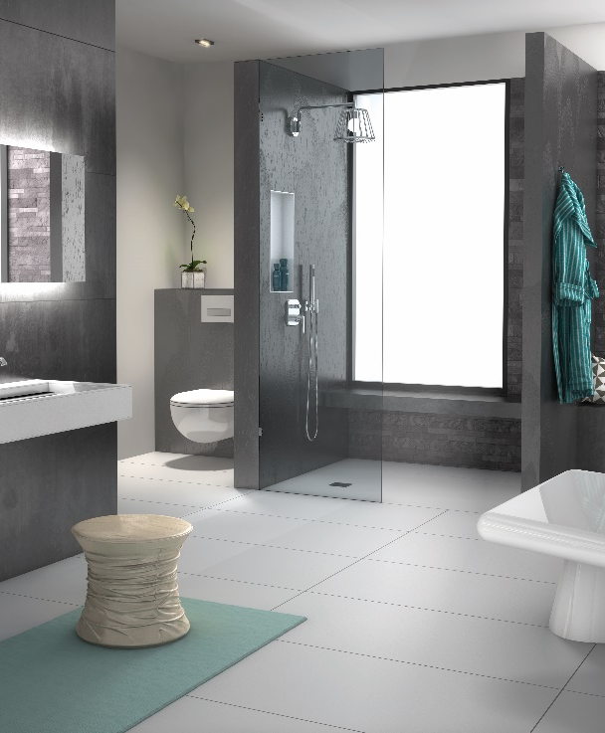
More creative freedom in the bathroom with the joint-free wedi Top line design surfaces.
Image can be downloaded from: https://www.bluemoon.de/kundendownload/wedi/wedi_Top_Line.jpg

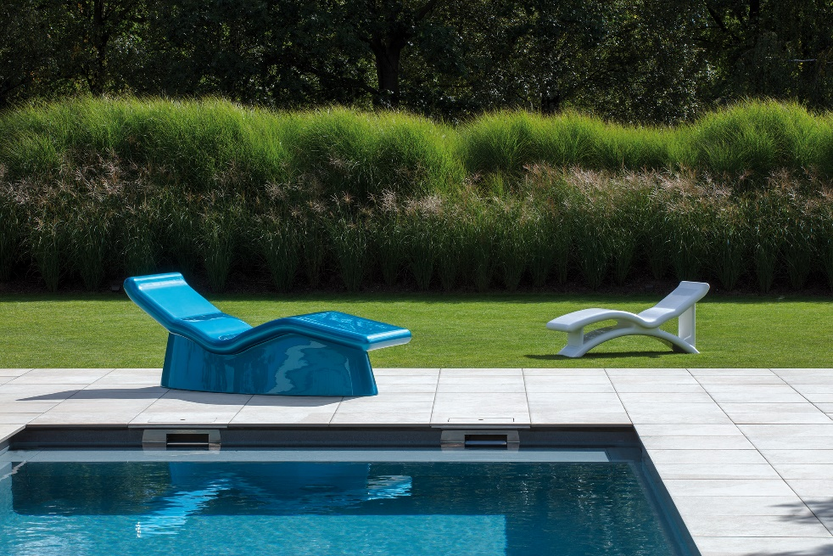
In the wedi Sanoasa Shine loungers, the Emsdetten system provider is introducing a high-quality and exclusive piece of furniture for use inside and outside.
Image can be downloaded from:
https://www.bluemoon.de/kundendownload/wedi/wedi_Sanoasa_Shine.jpg
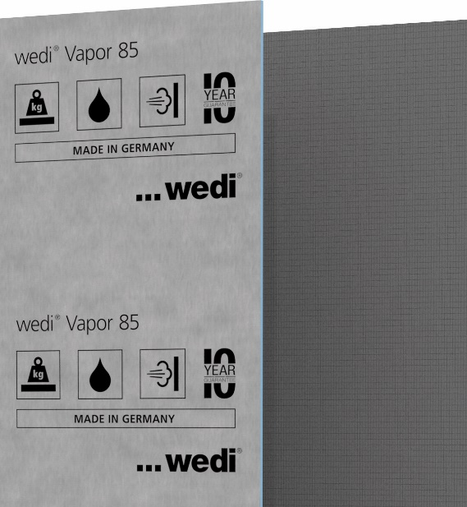
Ideal for rooms with increased humidity: wedi Vapor 85 has a sheet material seal with pre-installed vapour barrier.
Image can be downloaded from:
https://www.bluemoon.de/kundendownload/wedi/wedi_Vapor-85.jpg
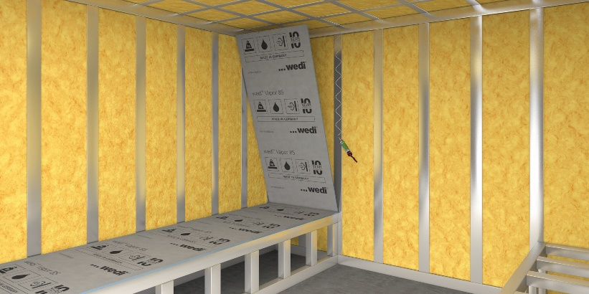
Simple installation: the Vapor 85 building board is easy to attach to stud frames using wedi 610. The joints are sealed with the new wedi 620 sealant and the wedi sealing tape.
Image can be downloaded from:
https://www.bluemoon.de/kundendownload/wedi/wedi_Vapor-85_wedi_620.jpg

All images: wedi

